AI Content Detection: A Comparative Analysis of BERT and RoBERTa on the HC3 Dataset
Md. Anjir Jaman, Tasfia Tofail, Hasibul Islam, Koushik Biswas Arko
American International University-Bangladesh
Dhaka, Bangladesh
22-49235-3@student.aiub.edu, 22-49231-3@student.aiub.edu, 22-48498-3@student.aiub.edu, 22-49234-3@student.aiub.edu,
Abstract
As Large Language Models (LLMs) like ChatGPT become increasingly sophisticated, distinguishing between human-written and AI-generated content has become a critical challenge for academic integrity and information security. This project aims to develop a robust AI content detection system using transfer learning. We fine-tuned and compared two Transformer-based architectures, BERT (Bidirectional Encoder Representations from Transformers) and RoBERTa (Robustly Optimized BERT Approach), on the HC3 (Human ChatGPT Comparison Corpus) dataset. Our experimental results demonstrate that while both models perform exceptionally well, RoBERTa outperforms the baseline BERT model. Specifically, RoBERTa achieved an Accuracy of 99.50% and a Precision of 98.96%, compared to BERT’s 97.67% accuracy and 95.32% precision. Both models achieved a perfect Recall of 100%, successfully identifying all AI-generated instances. These findings suggest that RoBERTa’s dynamic masking and larger pre-training corpus make it a superior choice for minimizing false positives in AI detection tasks.
1 Introduction
The rapid advancement of Large Language Models (LLMs) such as ChatGPT has blurred the line between human and machine-generated text. While these tools offer immense productivity benefits, they also pose significant risks, including academic dishonesty (plagiarism), the spread of misinformation, and automated spam generation. Consequently, there is an urgent need for reliable automated systems capable of distinguishing human and AI authorship.
The primary problem addressed in this project is the Binary Classification of Text, where the goal is to label a given text sequence as either "Human" or "AI". Traditional statistical methods often fail to capture the subtle semantic nuances and structural "burstiness" that differentiate human writing from machine output. To solve this, we employed Transfer Learning, leveraging pre-trained Transformer models which have achieved state-of-the-art results in various NLP tasks. Specifically, we implemented and compared BERT, the industry standard for language understanding, against RoBERTa, an optimized variant, to determine which architecture provides better sensitivity and lower false-positive rates for this specific domain.

2 Background
This section details the architectural differences between the two models used in this study.
2.1 BERT Architecture
BERT (Bidirectional Encoder Representations from Transformers), introduced by Google in 2018, revolutionized NLP by using a bidirectional training mechanism. Unlike previous models that read text sequentially (left-to-right or right-to-left), BERT reads the entire sequence of words at once using the Transformer encoder.
BERT is pre-trained on two specific tasks:
- Masked Language Modeling (MLM): Randomly masking 15% of the words in a sentence and training the model to predict them based on context. This allows the model to learn deep bidirectional representations.
- Next Sentence Prediction (NSP): The model is given pairs of sentences and trained to predict if the second sentence logically follows the first. This helps BERT understand sentence relationships.

2.2 RoBERTa Model Architecture
For this study, we selected RoBERTa (Robustly Optimized BERT Pretraining Approach) as our variant model. RoBERTa is an advanced iteration of the BERT architecture that modifies the pre-training procedure to improve performance. While it shares the same Transformer-based architecture as BERT, it introduces three critical changes:
- Dynamic Masking: Unlike BERT, which generates a static masking pattern for training data once, RoBERTa generates a unique masking pattern every time a sequence is fed into the model. This allows the model to see different versions of the same sentence, improving robustness.
- Removal of Next Sentence Prediction (NSP): Research showed that the NSP objective in BERT was unnecessary for performance. RoBERTa removes this, focusing entirely on the Masked Language Modeling (MLM) objective.
- Larger Mini-Batches and Data: RoBERTa was trained on a much larger dataset (160GB of text compared to BERT's 16GB) and used significantly larger batch sizes.

3 Methodology
The project workflow followed a standard supervised learning pipeline, as illustrated below.
Figure 1: Workflow
3.1 Data Collection
We utilized the HC3 (Human ChatGPT Comparison Corpus) dataset, available on Hugging Face. This dataset is specifically designed for AI detection research, containing paired questions with answers written by both humans (from domains like finance, medicine, and open-QA) and ChatGPT. For this project, we selected a balanced subset of 6,000 samples (3,000 Human, 3,000 AI) to ensure computational efficiency within the Google Colab environment.
3.2 Data Preprocessing
The raw data required several preprocessing steps:
- Label Encoding: Human answers were assigned the label 0 and ChatGPT answers were assigned the label 1.
- List Flattening: The raw dataset contained lists of answers; these were joined into single string sequences.
- Tokenization: We used the specific tokenizers for each model (bert-base-uncased and roberta-base). We applied Truncation and Padding to a maximum sequence length of 512 tokens to fit the model constraints.
- Splitting: The data was split into a Training Set (80%, 4,800 samples) and a Validation Set (20%, 1,200 samples) using a fixed random seed (42) to ensure both models were trained and tested on identical data.
3.3 Model Training
Both models were fine-tuned using the Hugging Face Trainer API. We used the AdamW optimizer, which is standard for Transformer models. The training was conducted for 3 Epochs, which was sufficient for the models to converge without overfitting, given the high quality of the pre-trained weights.
3.4 Model Evaluation
To evaluate performance, we used four key metrics:
- Accuracy: The overall percentage of correct predictions.
- Precision: The ratio of true AI detections to all texts flagged as AI (measure of false positives).
- Recall: The ratio of true AI detections to actual AI texts (measure of sensitivity).
- F1-Score: The harmonic mean of Precision and Recall.
4 Implementation
The system was implemented using Python in a Google Colab environment, utilizing a T4 GPU for hardware acceleration. The core libraries used were PyTorch for deep learning, Transformers for model architectures, Datasets for data loading, and Scikit-learn for metric calculation.
4.1 BERT
We implemented the BERT-base-uncased model. This model consists of 12 transformer layers, 768 hidden units, and 12 attention heads, totaling approximately 110 million parameters.
- Batch Size: 8 per device
- Learning Rate: 2e-5
- Weight Decay: 0.01
4.2 Another Model
We implemented the Roberta-base model. It shares a similar size configuration to BERT base (12 layers, 768 hidden units) but utilizes the optimized pre-training weights discussed in Section 2.
- Batch Size: 8 per device
- Learning Rate: 2e-5
- Weight Decay: 0.01
5 Result Analysis
The performance of the models was evaluated on the held-out test set of 1,200 samples.
Table 1: Performance Comparison
Model | Accuracy | Precision | Recall | F1-Score
BERT | 97.67% | 95.32% | 100.00% | 97.60%
RoBERTa | 99.50% | 98.96% | 100.00% | 99.48%

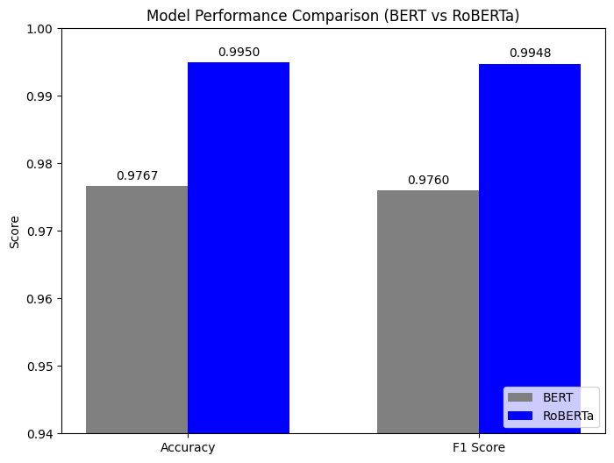
Figure 2: BERT vs RoBERTa Model Performance Comparison Chart

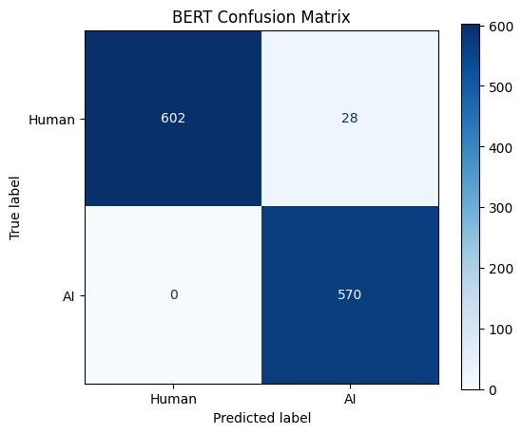
Figure 3 : BERT confusion matrix
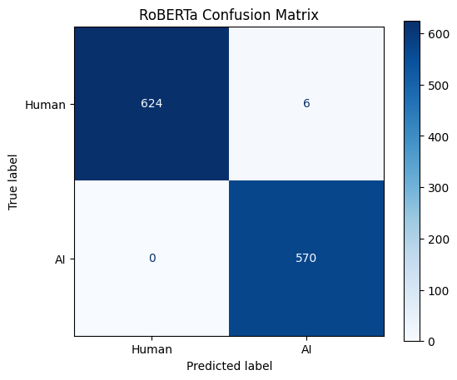
Figure 4 : RoBERTa confusion matrix
Discussion: Both models demonstrated exceptional capability in detecting AI-generated text, achieving a Recall of 1.0 (100%). This indicates that neither model missed a single instance of AI-generated content in the test set; every ChatGPT answer was correctly flagged.
However, RoBERTa outperformed BERT in Precision (98.96% vs 95.32%). The lower precision of the BERT model suggests it had a higher "False Positive" rate meaning it was more likely to incorrectly classify human-written text as AI-generated. RoBERTa's superior precision indicates it is better at discerning the subtle nuances of human writing, ensuring that genuine human content is not flagged as artificial. Consequently, RoBERTa achieved a higher overall Accuracy (99.50%) compared to BERT (97.67%).
6 Conclusion
In this project, we successfully implemented and evaluated two state-of-the-art NLP models for the binary classification task of detecting AI-generated text. By fine-tuning BERT and RoBERTa on the HC3 dataset, we observed that transfer learning is highly effective for this domain, with both models achieving over 97% accuracy.
Our comparative analysis revealed that RoBERTa is the superior model for this task. While both models demonstrated perfect sensitivity (Recall = 1.0) in catching AI content, RoBERTa provided significantly higher precision. This reduction in false positives is crucial for real-world applications, such as plagiarism detection, where incorrectly accusing a human author is a severe failure mode. Future work could explore the model's robustness against adversarial attacks, such as paraphrased AI text, or test its performance on newer LLMs like GPT-4.
References
1. Devlin, J., Chang, M. W., Lee, K., & Toutanova, K. (2018). BERT: Pre-training of Deep Bidirectional Transformers for Language Understanding. arXiv preprint arXiv:1810.04805.
2. Liu, Y., Ott, M., Goyal, N., Du, J., Joshi, M., Chen, D., ... & Stoyanov, V. (2019). RoBERTa: A Robustly Optimized BERT Pretraining Approach. arXiv preprint arXiv:1907.11692.
3. Guo, B., Zhang, X., Wang, Z., Jiang, M., Nie, J., Ding, Y., ... & Wu, Y. (2023). HC3: The Human ChatGPT Comparison Corpus. arXiv preprint arXiv:2301.07597.
Project Code
BERT code:
!pip install transformers datasets evaluate accelerate scikit-learn

import random
import numpy as np
import torch

def set_seed(seed_val=42):
random.seed(seed_val)
np.random.seed(seed_val)
torch.manual_seed(seed_val)
torch.cuda.manual_seed_all(seed_val)

set_seed(42)

import pandas as pd
import numpy as np
from datasets import load_dataset, Dataset
from transformers import AutoTokenizer, AutoModelForSequenceClassification, TrainingArguments, Trainer
from sklearn.metrics import accuracy_score, precision_recall_fscore_support

data_files = {"train": "https://huggingface.co/datasets/Hello-SimpleAI/HC3/resolve/main/all.jsonl"}
dataset = load_dataset("json", data_files=data_files)

df = pd.DataFrame(dataset["train"])

humans = pd.DataFrame()
humans["text"] = df["human_answers"].apply(lambda x: " ".join(x) if isinstance(x, list) else str(x))
humans["label"] = 0

ais = pd.DataFrame()
ais["text"] = df["chatgpt_answers"].apply(lambda x: " ".join(x) if isinstance(x, list) else str(x))
ais["label"] = 1

full_df = pd.concat([humans, ais])
full_df = full_df[full_df["text"].str.len() > 10]
full_df = full_df.sample(frac=1, random_state=42).reset_index(drop=True)
df_final = full_df.head(6000)

df_final.head(100).to_csv("sample_dataset.csv", index=False)

tokenizer = AutoTokenizer.from_pretrained("bert-base-uncased")

def tokenize_function(examples):
return tokenizer(examples["text"], padding="max_length", truncation=True, max_length=512)

hf_dataset = Dataset.from_pandas(df_final)
tokenized_datasets = hf_dataset.map(tokenize_function, batched=True)

small_train_dataset = tokenized_datasets.select(range(4800))
small_eval_dataset = tokenized_datasets.select(range(4800, 6000))

model = AutoModelForSequenceClassification.from_pretrained("bert-base-uncased", num_labels=2)

def compute_metrics(pred):
labels = pred.label_ids
preds = pred.predictions.argmax(-1)
precision, recall, f1, _ = precision_recall_fscore_support(labels, preds, average="binary")
acc = accuracy_score(labels, preds)
return {"accuracy": acc, "f1": f1, "precision": precision, "recall": recall}

training_args = TrainingArguments(
output_dir="bert_trainer",
eval_strategy="epoch",
num_train_epochs=3,
per_device_train_batch_size=8,
per_device_eval_batch_size=8,
learning_rate=2e-5,
weight_decay=0.01,
report_to="none"
)

trainer = Trainer(
model=model,
args=training_args,
train_dataset=small_train_dataset,
eval_dataset=small_eval_dataset,
compute_metrics=compute_metrics
)

trainer.train()
epoch | Training Loss | Validation Loss | Accuracy | F1 | Precision | Recall
1 | 0.096400 | 0.410937 | 0.930000 | 0.931373 | 0.871560 | 1.000000
2 | 0.011300 | 0.366882 | 0.942500 | 0.942928 | 0.892019 | 1.000000
3 | 0.000900 | 0.156350 | 0.976667 | 0.976027 | 0.953177 | 1.000000

metrics = trainer.evaluate()
print(metrics)
{'eval_loss': 0.15635043382644653, 'eval_accuracy': 0.9766666666666667, 'eval_f1': 0.976027397260274, 'eval_precision': 0.9531772575250836, 'eval_recall': 1.0, 'eval_runtime': 36.4053, 'eval_samples_per_second': 32.962, 'eval_steps_per_second': 4.12, 'epoch': 3.0}

import matplotlib.pyplot as plt
from sklearn.metrics import ConfusionMatrixDisplay

outputs = trainer.predict(small_eval_dataset)
y_pred = outputs.predictions.argmax(-1)
y_true = outputs.label_ids

fig, ax = plt.subplots(figsize=(6, 5))
ConfusionMatrixDisplay.from_predictions(y_true, y_pred, display_labels=["Human", "AI"], ax=ax, cmap="Blues")
plt.title("BERT Confusion Matrix")
plt.show()


RoBERTa Code :
!pip install transformers datasets evaluate accelerate scikit-learn

import random
import numpy as np
import torch

def set_seed(seed_val=42):
random.seed(seed_val)
np.random.seed(seed_val)
torch.manual_seed(seed_val)
torch.cuda.manual_seed_all(seed_val)

set_seed(42)

import pandas as pd
import numpy as np
from datasets import load_dataset, Dataset
from transformers import AutoTokenizer, AutoModelForSequenceClassification, TrainingArguments, Trainer
from sklearn.metrics import accuracy_score, precision_recall_fscore_support

data_files = {"train": "https://huggingface.co/datasets/Hello-SimpleAI/HC3/resolve/main/all.jsonl"}
dataset = load_dataset("json", data_files=data_files)

df = pd.DataFrame(dataset["train"])

humans = pd.DataFrame()
humans["text"] = df["human_answers"].apply(lambda x: " ".join(x) if isinstance(x, list) else str(x))
humans["label"] = 0

ais = pd.DataFrame()
ais["text"] = df["chatgpt_answers"].apply(lambda x: " ".join(x) if isinstance(x, list) else str(x))
ais["label"] = 1

full_df = pd.concat([humans, ais])

full_df = full_df[full_df["text"].str.len() > 10]
full_df = full_df.sample(frac=1, random_state=42).reset_index(drop=True)
df_final = full_df.head(6000)

df_final.head(100).to_csv("sample_dataset.csv", index=False)

tokenizer = AutoTokenizer.from_pretrained("roberta-base")
def tokenize_function(examples):
return tokenizer(examples["text"], padding="max_length", truncation=True, max_length=512)
hf_dataset = Dataset.from_pandas(df_final)
tokenized_datasets = hf_dataset.map(tokenize_function, batched=True)

small_train_dataset = tokenized_datasets.select(range(4800))
small_eval_dataset = tokenized_datasets.select(range(4800, 6000))

model = AutoModelForSequenceClassification.from_pretrained("roberta-base", num_labels=2)
def compute_metrics(pred):
labels = pred.label_ids
preds = pred.predictions.argmax(-1)
precision, recall, f1, _ = precision_recall_fscore_support(labels, preds, average="binary")
acc = accuracy_score(labels, preds)
return {"accuracy": acc, "f1": f1, "precision": precision, "recall": recall}

training_args = TrainingArguments(
output_dir="roberta_trainer",
eval_strategy="epoch",
num_train_epochs=3,
per_device_train_batch_size=8,
per_device_eval_batch_size=8,
learning_rate=2e-5,
weight_decay=0.01,
report_to="none"
)
trainer = Trainer(
model=model,
args=training_args,
train_dataset=small_train_dataset,
eval_dataset=small_eval_dataset,
compute_metrics=compute_metrics
)
trainer.train()
Epoch | Training Loss | Validation Loss | Accuracy | F1 | Precision | Recall
1 | 0.091200 | 0.058286 | 0.990833 | 0.990443 | 0.981067 | 1.000000
2 | 0.015500 | 0.145987 | 0.981667 | 0.981067 | 0.962838 | 1.000000
3 | 0.002900 | 0.031359 | 0.995000 | 0.994764 | 0.989583 | 1.000000

TrainOutput(global_step=1800, training_loss=0.030941605203681524, metrics={'train_runtime': 1483.2724, 'train_samples_per_second': 9.708, 'train_steps_per_second': 1.214, 'total_flos': 3788799197184000.0, 'train_loss': 0.030941605203681524, 'epoch': 3.0})

metrics = trainer.evaluate()
print(metrics)

{'eval_loss': 0.03135880082845688, 'eval_accuracy': 0.995, 'eval_f1': 0.9947643979057592, 'eval_precision': 0.9895833333333334, 'eval_recall': 1.0, 'eval_runtime': 31.8805, 'eval_samples_per_second': 37.641, 'eval_steps_per_second': 4.705, 'epoch': 3.0}

import matplotlib.pyplot as plt
from sklearn.metrics import ConfusionMatrixDisplay

outputs = trainer.predict(small_eval_dataset)
y_pred = outputs.predictions.argmax(-1)
y_true = outputs.label_ids

fig, ax = plt.subplots(figsize=(6, 5))
ConfusionMatrixDisplay.from_predictions(y_true, y_pred, display_labels=["Human", "AI"], ax=ax, cmap="Blues")
plt.title("RoBERTa Confusion Matrix")
plt.show()


import numpy as np
import matplotlib.pyplot as plt

bert_accuracy = 0.9767
bert_f1 = 0.9760

roberta_accuracy = metrics["eval_accuracy"]
roberta_f1 = metrics["eval_f1"]

labels = ['Accuracy', 'F1 Score']
bert_scores = [bert_accuracy, bert_f1]
roberta_scores = [roberta_accuracy, roberta_f1]

x = np.arange(len(labels))
width = 0.35

fig, ax = plt.subplots(figsize=(8, 6))
rects1 = ax.bar(x - width/2, bert_scores, width, label='BERT', color='gray')
rects2 = ax.bar(x + width/2, roberta_scores, width, label='RoBERTa', color='blue')

ax.set_ylabel('Score')
ax.set_title('Model Performance Comparison (BERT vs RoBERTa)')
ax.set_xticks(x)
ax.set_xticklabels(labels)
ax.legend(loc='lower right')
ax.set_ylim(0.94, 1.00)

def autolabel(rects):
for rect in rects:
height = rect.get_height()
ax.annotate(f'{height:.4f}', xy=(rect.get_x() + rect.get_width() / 2, height),
xytext=(0, 3), textcoords="offset points", ha='center', va='bottom')

autolabel(rects1)
autolabel(rects2)

plt.show()


